ROAD ACCIDENT ANALYSIS SQL QUERIES

TOTAL CASUALTIES

SELECT SUM(Number_of_Casualties) AS Total_Casualties

FROM [Road_Accident Data]

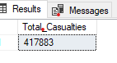

FATAL SEVERITY

SELECT SUM(Number_of_Casualties) AS Fatal_Casualties

FROM [Road_Accident Data]

WHERE Accident_Severity = 'Fatal'

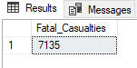

SERIOUS SEVERITY

SELECT SUM(Number_of_Casualties) AS Serious_Casualties

FROM [Road_Accident Data]

WHERE Accident_Severity = 'Serious'

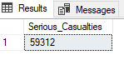

SLIGHT SEVERITY

SELECT SUM(Number_of_Casualties) AS Slight_Casualties

FROM [Road_Accident Data]

WHERE Accident_Severity = 'Slight'



FATAL SEVERITY PERCENTAGE OF TOTAL

SELECT CAST(CAST(SUM(Number_of_Casualties) AS DECIMAL(10,2))*100/

(SELECT CAST(SUM(Number_of_Casualties) AS DECIMAL (10,2 ))FROM [Road_Accident Data]) AS DECIMAL(3,1)) AS Fatal_PCT

FROM [Road_Accident Data]

WHERE Accident_Severity = 'Fatal'

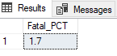

SERIOUS SEVERITY PERCENTAGE OF TOTAL

SELECT CAST(CAST(SUM(Number_of_Casualties) AS DECIMAL(10,2))*100/

(SELECT CAST(SUM(Number_of_Casualties) AS DECIMAL (10,2 ))FROM [Road_Accident Data]) AS DECIMAL(3,1)) AS Serious_PCT

FROM [Road_Accident Data]

WHERE Accident_Severity = 'Serious'

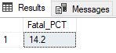

SLIGHT SEVERITY PERCENTAGE OF TOTAL

SELECT CAST(CAST(SUM(Number_of_Casualties) AS DECIMAL(10,2))*100/

(SELECT CAST(SUM(Number_of_Casualties) AS DECIMAL (10,2 ))FROM [Road_Accident Data]) AS DECIMAL(3,1)) AS Slight_PCT

FROM [Road_Accident Data]

WHERE Accident_Severity = 'Slight'



TOTAL CASUALTIES BY VEHICLE TYPE

SELECT

CASE

WHEN Vehicle_Type IN ('Agricultural vehicle') THEN 'Agriculture'

WHEN Vehicle_Type IN ('Taxi/Private hire car', 'Car') THEN 'Car'

WHEN Vehicle_Type IN ('Bus or coach (17 or more pass seats)','Minibus (8 - 16 passenger seats)') THEN 'Bus'

WHEN Vehicle_Type IN ('Van / Goods 3.5 tonnes mgw or under','Goods over 3.5t. and under 7.5t','Goods 7.5 tonnes mgw and over') THEN 'Van'

WHEN Vehicle_Type IN ('Motorcycle over 500cc','Motorcycle 50cc and under','Motorcycle 125cc and under','Motorcycle over 125cc and up to 500cc') THEN 'Motocycle'

ELSE 'Other'

END AS Vehicle_Group,

SUM(Number_of_Casualties) AS Casualties

FROM [Road_Accident Data]

GROUP BY

CASE

WHEN Vehicle_Type IN ('Agricultural vehicle') THEN 'Agriculture'

WHEN Vehicle_Type IN ('Taxi/Private hire car', 'Car') THEN 'Car'

WHEN Vehicle_Type IN ('Bus or coach (17 or more pass seats)','Minibus (8 - 16 passenger seats)') THEN 'Bus'

WHEN Vehicle_Type IN ('Van / Goods 3.5 tonnes mgw or under','Goods over 3.5t. and under 7.5t','Goods 7.5 tonnes mgw and over') THEN 'Van'

WHEN Vehicle_Type IN ('Motorcycle over 500cc','Motorcycle 50cc and under','Motorcycle 125cc and under','Motorcycle over 125cc and up to 500cc') THEN 'Motocycle'

ELSE 'Other'

END

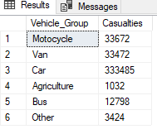

CY VS PY MONTHLY TREND

SELECT DATENAME(MONTH,Accident_Date) AS Month_Name,

SUM(Number_of_Casualties) AS CY_Casualties

FROM [Road_Accident Data]

WHERE YEAR(Accident_Date)= '2022'

GROUP BY DATENAME(MONTH,Accident_Date)

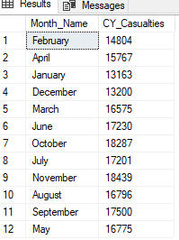

SELECT DATENAME(MONTH,Accident_Date) AS Month_Name,

SUM(Number_of_Casualties) AS PY_Casualties

FROM [Road_Accident Data]

WHERE YEAR(Accident_Date)= '2021'

GROUP BY DATENAME(MONTH,Accident_Date)

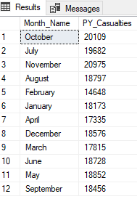

CASUALITIES BY ROAD TYPE

SELECT Road_Type, SUM(Number_of_Casualties)AS Casualties

FROM [Road_Accident Data]

GROUP BY Road_Type

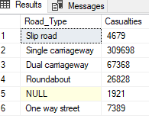

CASUALTIES BY ROAD SURFACE

SELECT

CASE

WHEN Road_Surface_Conditions IN ('Dry') THEN 'Dry'

WHEN Road_Surface_Conditions IN ('Wet or damp','Flood over 3cm. deep') THEN 'Wet'

WHEN Road_Surface_Conditions IN ('Frost or ice','Snow') THEN 'Ice'

ELSE 'Other'

END AS Road_Surface_Conditions_Group,

SUM(Number_of_Casualties) as Casualties

FROM [Road_Accident Data]

GROUP BY

CASE

WHEN Road_Surface_Conditions IN ('Dry') THEN'Dry'

WHEN Road_Surface_Conditions IN ('Wet or damp','Flood over 3cm. deep') THEN 'Wet'

WHEN Road_Surface_Conditions IN ('Frost or ice','Snow') THEN 'Ice'

ELSE 'Other'

END

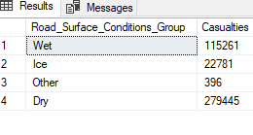

CASUALTIES BY LIGHT CONDITIONS

SELECT

CASE

WHEN Light_Conditions IN ('Darkness - lighting unknown','Darkness - lights lit', 'Darkness - lights unlit','Darkness - no lighting') THEN 'Night'

ELSE 'Day'

END AS Light_Condition_Group,

SUM(Number_of_Casualties) as Casualties

FROM [Road_Accident Data]

GROUP BY

CASE

WHEN Light_Conditions IN ('Darkness - lighting unknown','Darkness - lights lit', 'Darkness - lights unlit','Darkness - no lighting') THEN 'Night'

ELSE 'Day'

END

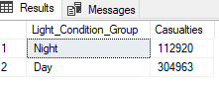

CASUALTIES BY URBAN OR RURAL AREA

SELECT Urban_or_Rural_Area,

SUM (Number_of_Casualties) AS Casualties

FROM [Road_Accident Data]

GROUP BY Urban_or_Rural_Area

